**Rajan Gautam**

**19BCP101**

**Div. II, CE 19**

**SOT, PDPU**

**Pandit Deendayal Petroleum University**

**School of Technology**

**Design & Analysis of Algorithm (20CP209P)**

**B. Tech - Computer Science & Engineering (Sem-IV)**

**Table of Contents**

**Lab 1 Assignment: Comparison of Insertion Sort & Bubble Sort 1**

**AIM: To write a C/C++ Program to implement Insertion Sort & Bubble Sort. 1**

**ALGORITHMS: 1**

**1. Insertion Sort Algorithm (Pseudocode) 1**

**2. Bubble Sort Algorithm (Pseudocode) 1**

**CODE: 1**

**OUTPUT: 4**

**COMPARISON: 4**

# Lab 1 Assignment: Comparison of Insertion Sort & Bubble Sort

## AIM: To write a C/C++ Program to implement Insertion Sort & Bubble Sort.

## ALGORITHMS:

### Insertion Sort Algorithm (Pseudocode)

**INSERTION-SORT (A, n)**

**for j 🡨 2 to n**

**Do key 🡨 A[j]**

**i 🡨 j – 1**

**while i > 0 and A[i] > key**

**Do A [i + 1] 🡨 A[i]**

**i 🡨 i – 1**

**A [i + 1] = key**

### Bubble Sort Algorithm (Pseudocode)

**BUBBLE-SORT (A, n)**

**For i 🡨 1 to N do**

**For j = 0 to N – 1 do**

**If A[j] > A[j+1] then**

**Temp = A[j]**

**A[j] = A[j+1]**

**A[j+1] = temp**

## CODE:

1. **/* ------------------------- 19BCP101 -----------------------*/**
2. **/* ----------------------- Rajan Gautam ---------------------*/**
4. **#include <stdio.h>**
5. **#include <stdlib.h>**
6. **#include <time.h> // For Time Calculation**
8. **// Function for Insertion Algorithm**
9. **void insertion_sort(int A[], int n)**
10. **{**
11. **int i, j, key;**
12. **for(i = 1; i < n; i++)**
13. **{**
14. **key = A[i];**
15. **j = i - 1;**
16. **while (j >= 0 && A[j] > key)**
17. **{**
19. **A[j+1] = A[j];**
20. **j = j -1;**
21. **}**
22. **A[j+1] = key;**
23. **}**
24. **}**
26. **// Function for Bubble Sort Algorithm**
27. **void bubble_sort(int A[], int n)**
28. **{**
29. **int i, j, temp;**
30. **for (i = 0; i < n-1; i++)**
31. **{**
32. **for (j = 0; j < n-i-1; j++)**
33. **{**
34. **if (A[j] > A[j+1])**
35. **{**
36. **temp=A[j];**
37. **A[j]=A[j+1];**
38. **A[j+1]=temp;**
39. **}**
40. **}**
41. **}**
42. **}**

45. **int main()**
46. **{**
47. **printf("<--------------- Sorting --------------->\n\n");**
49. **int n = 1000, it = 0;**
50. **double time1[20], time2[20]; // To store the time values**
52. **printf(" Array | Bubble(s) | Insertion(s) \n\n");**
54. **while(it++ < 10)**
55. **{**
56. **long int a[n], b[n];**
57. **for (int i = 0; i < n ; i++)**
58. **{**
59. **// Generating Random Integer Array for each algorithm**
61. **a[i] = (rand() % n);**
62. **b[i] = (rand() % n);**
63. **}**

66. **// For time calculation**
67. **clock_t start, end;**

70. **// For Bubble Sort Algorithm**
71. **start = clock();**
72. **bubble_sort(a, n);**
73. **end = clock();**
75. **time1[it] = ((double)(end - start)/CLOCKS_PER_SEC);**

78. **// For Insertion Algorithm**
79. **start = clock();**
80. **insertion_sort(b, n);**
81. **end = clock();**
83. **time2[it] = ((double)(end - start)/CLOCKS_PER_SEC);**
85. **// Printing the table of array size, time taken by Bubble Sort and Insertion Algorithm**
86. **printf(" %d | %f | %f\n", n, time1[it], time2[it]);**

89. **// Incrementing the value of n by 1000**
90. **n += 1000;**
91. **}**
92. **return 0;**
93. **}**

## OUTPUT:

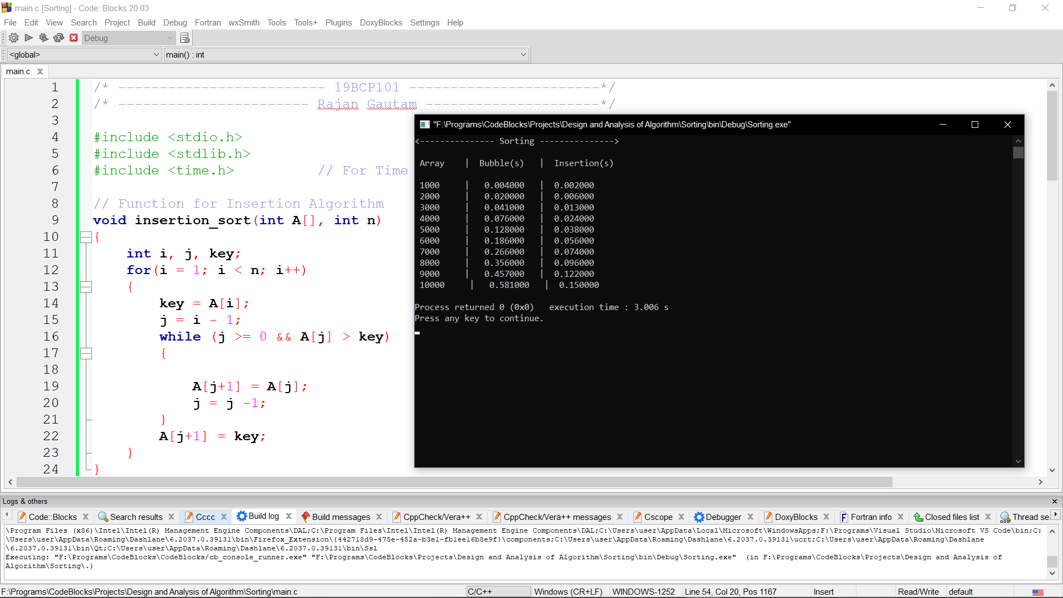

## COMPARISON: